B.Sc Botany 2nd Semester

FYUGP 2024

Prepared by: KASHMITA OJAH(Ast. Prof.)

PLASMA MEMBRANE
Every cell is surrounded by a thin, elastic semipermeable membrane called as plasma membrane. It serves as a boundary for the cytoplasm.
The term plasma membrane was coined by Nageli and Crammer in 1855. It is also called as cell membrane or plasmalemma.
Plasma membrane is outer limiting membrane in all animal cells. But in plant cells and bacterial cells, it is present inner to the cell wall. The plasma membrane separates the cytoplasm from the surrounding cellular environment. It is semipermeable membrane and plays a passive role in the exchange of molecules between the cell and its surroundings.

Chemical Composition:
The plasma membrane is mainly composed of proteins, lipids and a small proportion of carbohydrates. The lipid protein ratio varies with cell types.
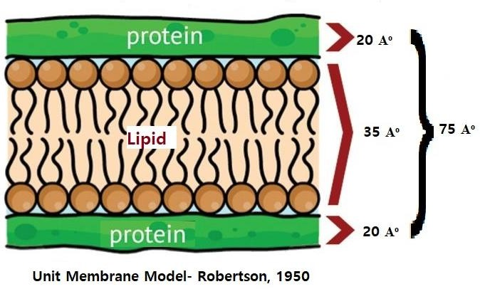
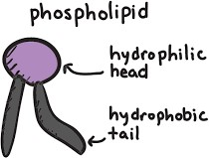

Lipids:
The plasma membrane contains about 20-79 % of lipids. There are several lipids present in the plasma membrane. The main lipid components are phospholipids, glycolipids and sterols (Cholesterol).
The lipids of plasma membrane are amphipathic in nature. It consists of a head and two tails. The head is hydrophilic and polar while the tails are hydrophobic and non-polar. The lipid molecules form a double layer in the plasma membrane. The tails are oriented inwards and the heads facing outwards.

Proteins:
The proteins of plasma membrane have high molecular weight. Three different classes of proteins occur in the plasma membrane—Structural proteins, Carrier proteins and enzymes.
The structural proteins form backbone of the cell membrane. The carrier proteins are involved in the active transport. The enzymes include ATPase, Phosphatase, Hexokinase, RNAase and esterase.
The proteins serve as carriers or channels for transport. They are also involved in the regulatory or signaling functions.

Carbohydrates:
In plasma membrane carbohydrates are present in the form of covalently-linked molecules with proteins and lipids.
These are of two types: - glycoproteins and glycolipids.

Molecular Models of plasma membrane:
The structure of plasma membrane has been interpreted in various ways by different cell biologists.
  - Trilaminar model (Robertson, 1950)
  - Biomoleular leaflet model (Danialli Davson, 1934)
  - Lattice model (Wolpers, 1941)
  - Micellar model (Hilleir & Hoffman, 1955)
  - Fluid mosaic model

Structure of Plasma Membrane:
Fluid Mosaic Model:
The fluid mosaic model was proposed by Singer and Nicolson in 1972 to describe the structure of plasma membrane. According to this model, lipids are in the form of fluid bilayer and the proteins do not form a covering of hydrophilic lipid bilayer. The membrane proteins are partially or wholly embedded in the bi-layer.
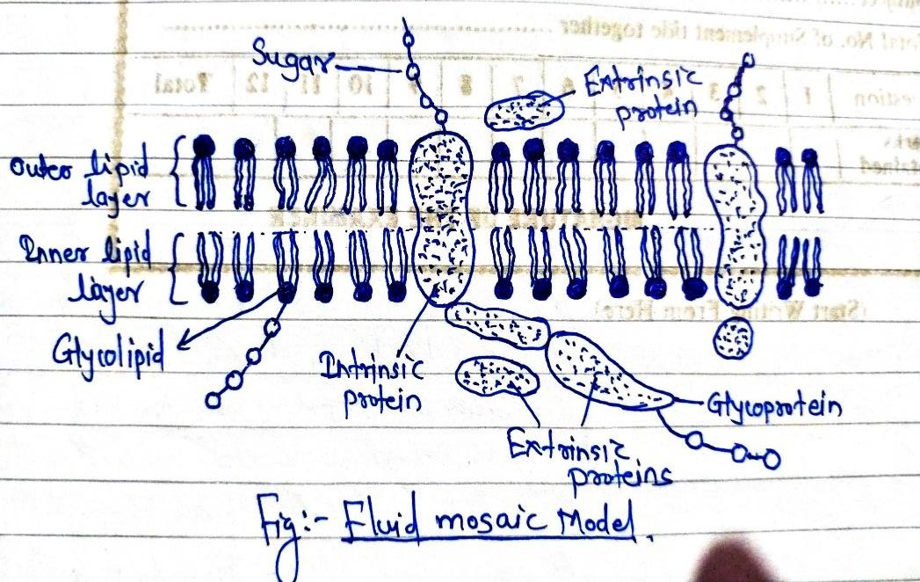

According to this model, the plasma membrane consists of lipids and proteins. The lipid is in the form of fluid and the proteins are embedded here and therein the lipid in a mosaic pattern. Hence the name is fluid mosaic model.
The lipids are arranged in the form of two layers, an outer layer and an inner layer. The proteins do not form layer. Each lipid molecule has a hydrophilic head and hydrophobic tail. The heads face outwards and the tails of the two layers face each other.
Lipid molecules are not rigidly positioned in their places. They are always in a constant motion and undergo lateral diffusion. The proteins bound with them also moves drastically.
The protein molecules are globular and are of two types: 1) Peripheral or Extrinsic proteins

2) Integral or Intrinsic proteins
The peripheral proteins are arranged on the surface and are loosely bound to the lipid. The integral proteins are deeply embedded and are tightly bound to the lipid molecules. The peripheral proteins as well as the outer part of integral proteins are studded with sugars. Such proteins with attached sugars are called glycoproteins. Similarly, sugars are also attached to the outer surface of some lipids. These lipids with attached sugars are called glycolipids.

If the extrinsic proteins are removed from the membrane, there is no disruption in the membrane structure. But if intrinsic proteins are removed, the membrane structure is disrupted.

The carbohydrates found in intrinsic proteins and glycolipids form a sugar covering called glycocalyx. It recognizes certain foreign proteins and protects the cell from extracellular digestive fluids.
The fluid mosaic model stresses that the plasma membrane is semi-fluid in nature. The lipids and intrinsic proteins move freely within the lipid bilayer.
Fluid mosaic model is the most accepted model because it convincingly explains the transport through the membrane.

Transport across membranes:
The main function of the plasma membrane is to regulate the flow of materials in and out of the cell called transport. This transport of material is regulated by the size of pores present in the plasma membrane. Plasma membrane is semi-permeable which allows the passage of a solvent but not of all solutes.
Plasma membrane allows the needed materials to enter the cell and sends out the unwanted materials from the cell. This property of the plasma membrane is called selective permeability.
Transport of metabolites through plasma membrane takes place in different ways:
- Passive Transport: i) Simple diffusion
  - Facilitated diffusion
- Active Transport: i) Primary active transport
  - Secondary active transport

Passive Transport:
Passive transport is a type of membrane transport that does not require energy to move substances across cell membranes.

The movement of molecules across the plasma membrane from the region of higher concentration to a region of lower concentration is called passive transport.

Simple Diffusion:
Simple diffusion is the passive movement of solute from a high concentration to a lower concentration until the concentration of the solute is uniform throughout and reaches equilibrium. Simple diffusion is the forms of passive transport and require none of the cell's ATP energy.
Simple diffusion is a form of diffusion that does not require the assistance of membrane proteins. The particle or substance moves from higher to lower concentration. However, its movement does not need a membrane protein that will help substances to move through plasma membrane.
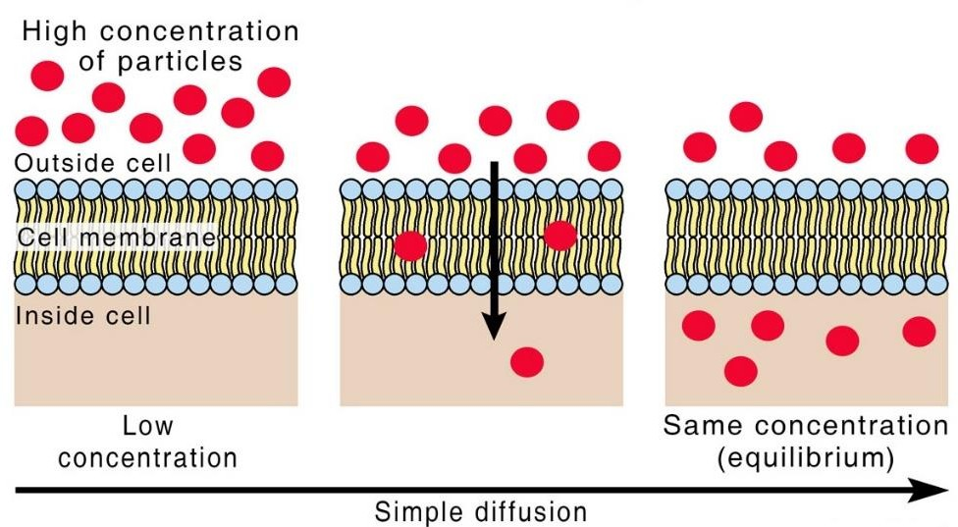

Facilitated Diffusion:
It involves the use of membrane proteins (Channels and carriers) to facilitate the movement of molecules in either direction across a membrane. In this type of diffusion, energy is not required and it takes place along the concentration gradient. However, it differs from simple diffusion in some respects-
    - It requires carrier for transport of the metabolite across the membrane
    - It Is a stereo specific process i.e., only one isomer is transported.

The role of carrier protein is simply to facilitate the diffusion of a polar or charged solute. Carriers are proteins with relatively low molecular weight (9 to 40,000) but they are highly selective. The metabolite binds to the carrier protein at the outer surface of the membrane to form carrier metabolite complex. This diffuses along the concentration gradient i.e., from high concentration to low concentration regions.

The metabolite is then released towards the inner surface of the membrane as there is low concentration of metabolites on the inner side. It is continued as long as a concentration gradient is developed. The transport of glucose into the erythrocytes is a good example of facilitated diffusion.

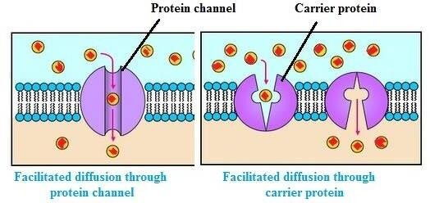

Active Transport:
The movement of molecules and ions from the region of lower concentration to the region of higher concentration, against the concentration gradient is called active transport. The transport takes place from region of low concentration to high concentration using an input of energy. This energy is provided by the mitochondria.
In this case, substances do not move by themselves, but they are carried by some carriers present in membrane. These carriers are mainly proteins. This form of transport requires energy and carriers.

In primary active transport, the energy obtained by ATP hydrolysis used directly for transport. E.g., Na⁺-K⁺ pump

In secondary active transport, indirect energy source is required. E.g., transport of glucose and amino acids is coupled to active transport of Na⁺.
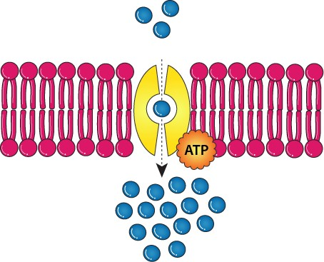

Endocytosis:
It is the bulk transport of materials into the cells by vesicles. Vesicle formation takes place by in-folding of the cell membrane. It does not occur in plant cells due to rigid cell wall.
It is the engulfing of food or foreign particles through the plasma membrane. There are two types of endocytosis: 1) Phagocytosis
2) Pinocytosis

Phagocytosis: (Cell eating)
(Greek- Phagein= to eat; kytos= cell)
The cell ingests or swallows foreign bodies, bacteria, harmful matter and other inert substances and the process is called phagocytosis.
It is the engulfing of solid particles through the plasma membrane. It is observed in number of protozoans and leucocytes. The cells exhibiting phagocytosis are called phagocytes.
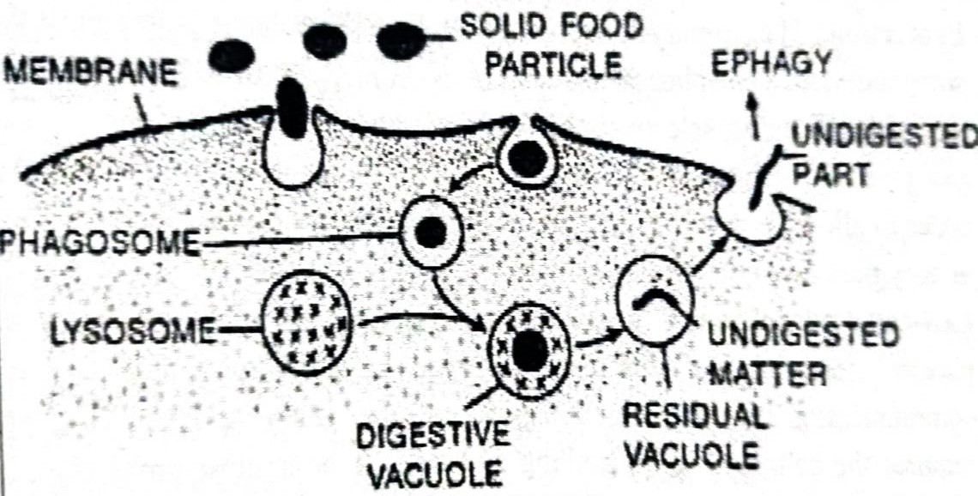
Fig. Phagocytosis

The solid particles are absorbed at the surface of plasma membrane. Later on, they are taken into the cytoplasm by the infoldings of plasma membrane. The plasma membrane gets pinched off in the form of small vesicle called phagosomes. Then the phagosomes fuse with lysosomes to form the digestive vacuoles. The food is digested inside the vacuole and the digested food diffuses into the cytoplasm. The vacuole containing undigested food is called residual vacuole. The undigested food particles are thrown out by the process of exocytosis.

Pinocytosis: (Cell drinking)
(Greek- Pinetin= to drink; kytos= cell)
It is the process of engulfing fluid particles through the plasma membrane.
Intake of fluid material into the cell by the formation of pinocytic vesicles or pinosomes is called pinocytosis.

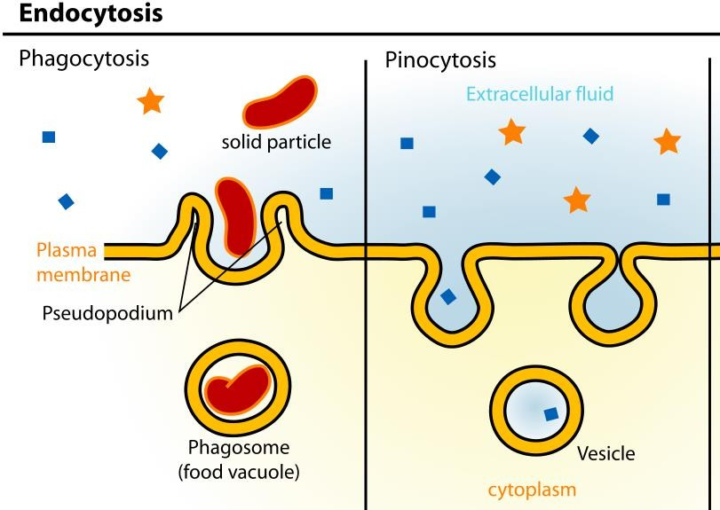

Fluids in contact with the plasma membrane move through temporarily formed deep invaginations into the cell. The plasma membrane gets pinched off in the form of small vesicles called pinosomes. The pinosomes empty their contents in the cytoplasm. Pinocytosis is found in protozoa and best studied in amoeba.

- Exocytosis: (Cell vomiting)
The process of exudating the secretory products from the secretory cells to the outsid e of the cell is called exocytosis. It is also called as reverse endocytosis.
